Kulaluk Areas of Significance, Burial Grounds, Ceremony Grounds
1. Map from Hollingsworth Consultants (1985) Kulaluk Lease Area Land Development Study.
Based on previous map by Aboriginal Sacred Sites Protection Authority, 1983.
2. Map from Henderson, Krimhilde (1983) Land Use Field Study of the Kulaluk Area, Aboriginal Sacred Sites Protection Authority.

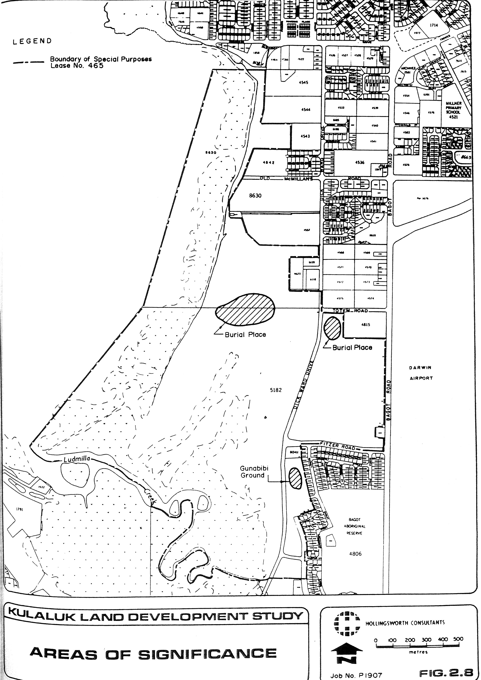
Map from Henderson, Krimhilde (1983) Land Use Field Study of the Kulaluk Area, Aboriginal Sacred Sites Protection Authority.

